

Pre-board Examination - 2023
Subject: IT 238: Data Structure and Algorithm FM:60
Semester: BIM 3rd Semester Time: 3 hrs
Group A
Attempt all the questions. (10x1=10)
- How can DSA can be implemented in the real life systems?
- What is Merge sort?
- What is binary search?
- Why worst case is widely used in algorithm design than best and average case complexity?
- How java uses the import java.util.Arrays class ?
- Define expression. What are the different types of expression available in DSA?
- How the AVL tree is balanced? Write all the scenarios.
- Difference between tail and non - tail recursion.
- Write short step for the working of Radix sort.
- What is Shell Sort in java.
Group B
Attempt any five Questions. (5x3=15)
- Write a java function to delete an element from specific position in doubly linked list.
- Write a program to implement tower of honai in java.
- Write a program to implement quick sort in java.
- Explain Depth first search with example.
- Complete the binary search for the following data:
5 9 17 23 25 45 59 63 71 89
- Convert infix expression to postfix expression:
(A/B^C+D*E-A*C)

Group C (3x5=15)
Attempt any three but Question no. 1 is compulsory.
- Find the shortest path cost between all pairs vertices in the graph.
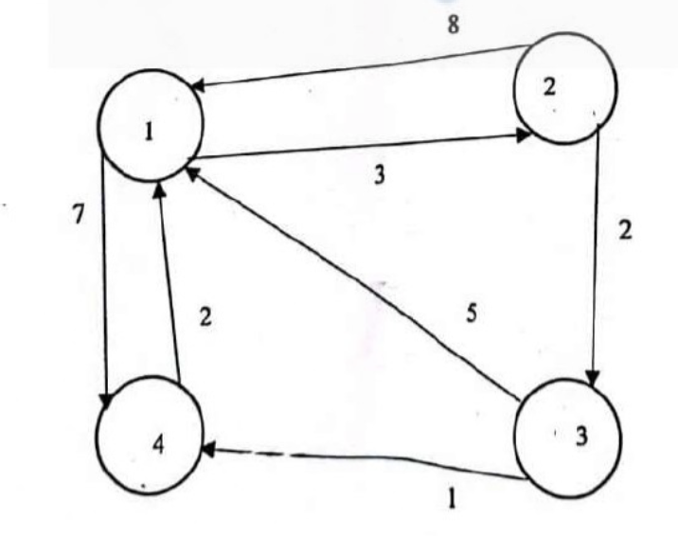
- Write all possible topological sorts from the following graph.
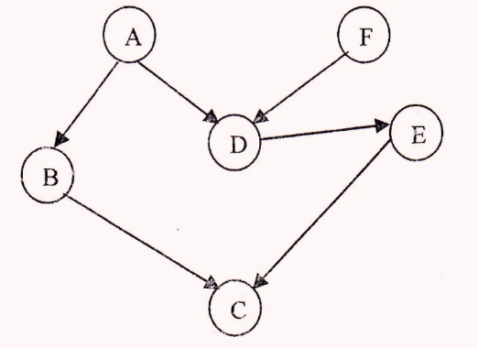
- Create the AVL tree from the following:
1, 17, 16, 18, 20, 21, 22, 31, 30, 39
- Insert the following data in the hash table, where the table size is 100.
82, 47, 48, 71, 98, 10, 37,69, 22, 82
Use any suitable collision technique in case of collision occurs.

Group D
Attempt all the questions.(2x10=20)
- Write the rules for Almost Complete Binary tree (ACBT). (1)
Explain the cases of below into BST with example.
- Inserting (2)
- Deletion (4)
- Searching element (3)
- Define minimum spanning tree. Write the algorithm for Kruskal and prims algorithm. Find the minimum shortest path weight using Kruskal and prims algorithm with every steps.

